**Technical Document for City Hall Co2 Levels**

Technical Requirements:

1. Java 11 and Above.
2. Maven 3.6.2
3. IDE
4. Spring initializer
5. H2 dependencies

Requirements:

A Restful Web service using Spring boot to show Co2 levels for City Hall.

Since we will be working without COBOL and Thunderhead we will hardcode the data in h2 database.

Architecture:

1. POJO classes for Carbon sensors, District and City.
2. There will be corresponding Repository Interface for the same to perform the CRUD operations.
3. There will be controller classes for the interaction with the APi or Postman to GET/Put/Post/delete operation.
4. A wrapper i.e service Layer will be made to Interact with the controller and the Repository.
5. Data will be saved via a class called Bootstrap to show in h2 console.
6. We are also able to hit request via Postman.

Controller

Database

Repository

Service

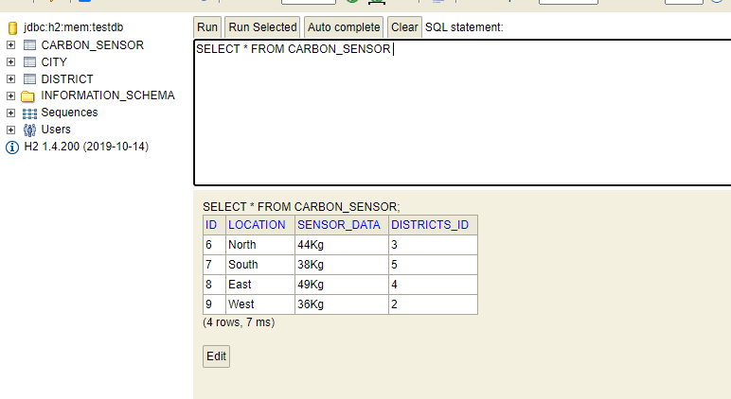

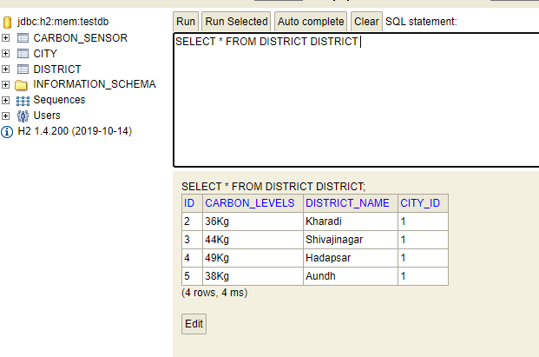

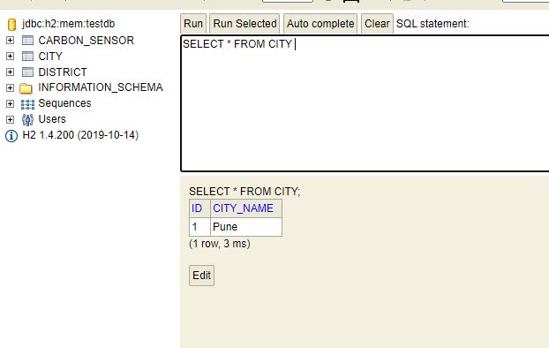

These screenshots are the sample data from the Bootstrap class.